**Max Score = 15 points**

CS 250 2018 Spring Homework 01

This assignment is due at 11:59:00 pm Thursday, January 18, 2018.

Upload your typewritten answer document in either PDF or Word format to Blackboard. Download from Blackboard to be sure that your upload was successful.

Your last upload that is not marked “LATE” by Blackboard is the upload that will be graded. There is no “grace” period for late uploads

**ADVICE:** Upload your solution sufficiently before the deadline to avoid internet congestion issues and server not responding issues.

The policy for all homework assignments this semester is as follows. Please sign, which you may do by typing in your name on the signature line.

*In the following I have not represented the work of another person as my own nor have I knowingly or actively assist another person in violating this standard.*

**(Signed)__________Liu Dayu____________**

1. Create a single truth table that defines all possible one-input Boolean functions. At the appropriate place in the truth table give your best idea for the name of each function.

|  |  |  |
| --- | --- | --- |
| FUNCTION | INPUT | OUTPUT |
| FALSE | 0 | 0 |
| FALSE | 1 | 0 |
| TRUE | 0 | 1 |
| TRUE | 1 | 1 |
| NOT | 0 | 1 |
| NOT | 1 | 0 |
| SAME | 0 | 0 |
| SAME | 1 | 1 |

1. What is the truth table for the three-input NOR(A,B,C) function? Draw the circuit for the 3-input NOR gate and the level of abstraction of the CMOS transistor. You may hand draw circuit and then scan them into your document here.

|  |  |  |  |
| --- | --- | --- | --- |
| INPUT X | INPUT Y | INPUT Z | OUTPUT |
| 0 | 0 | 0 | 1 |
| 0 | 0 | 1 | 0 |
| 0 | 1 | 0 | 0 |
| 0 | 1 | 1 | 0 |
| 1 | 0 | 0 | 0 |
| 1 | 0 | 1 | 0 |
| 1 | 1 | 0 | 0 |
| 1 | 1 | 1 | 0 |

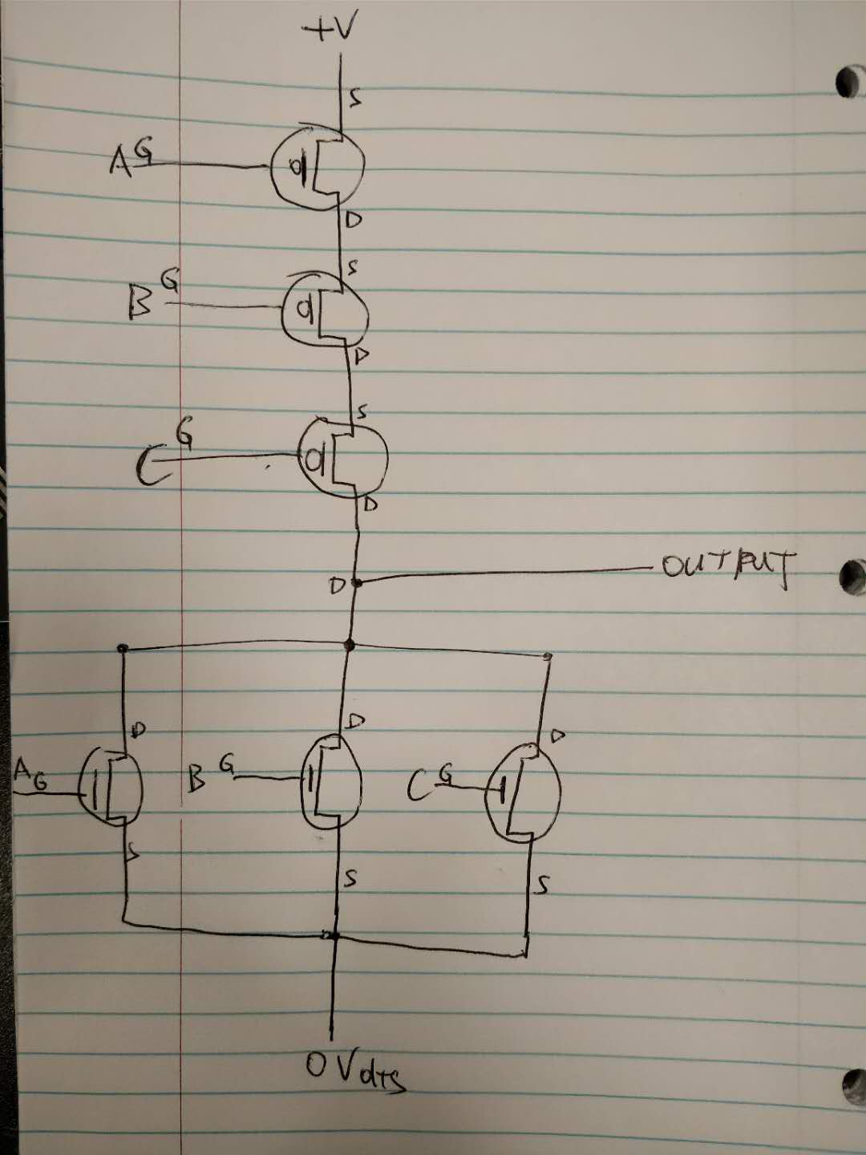

1. Using exactly 4 CMOS transistors, design and then draw a schematic for an AND circuit. Comment on the relationship you see between the NAND circuit presented in class and our textbook and the AND circuit that you develop.

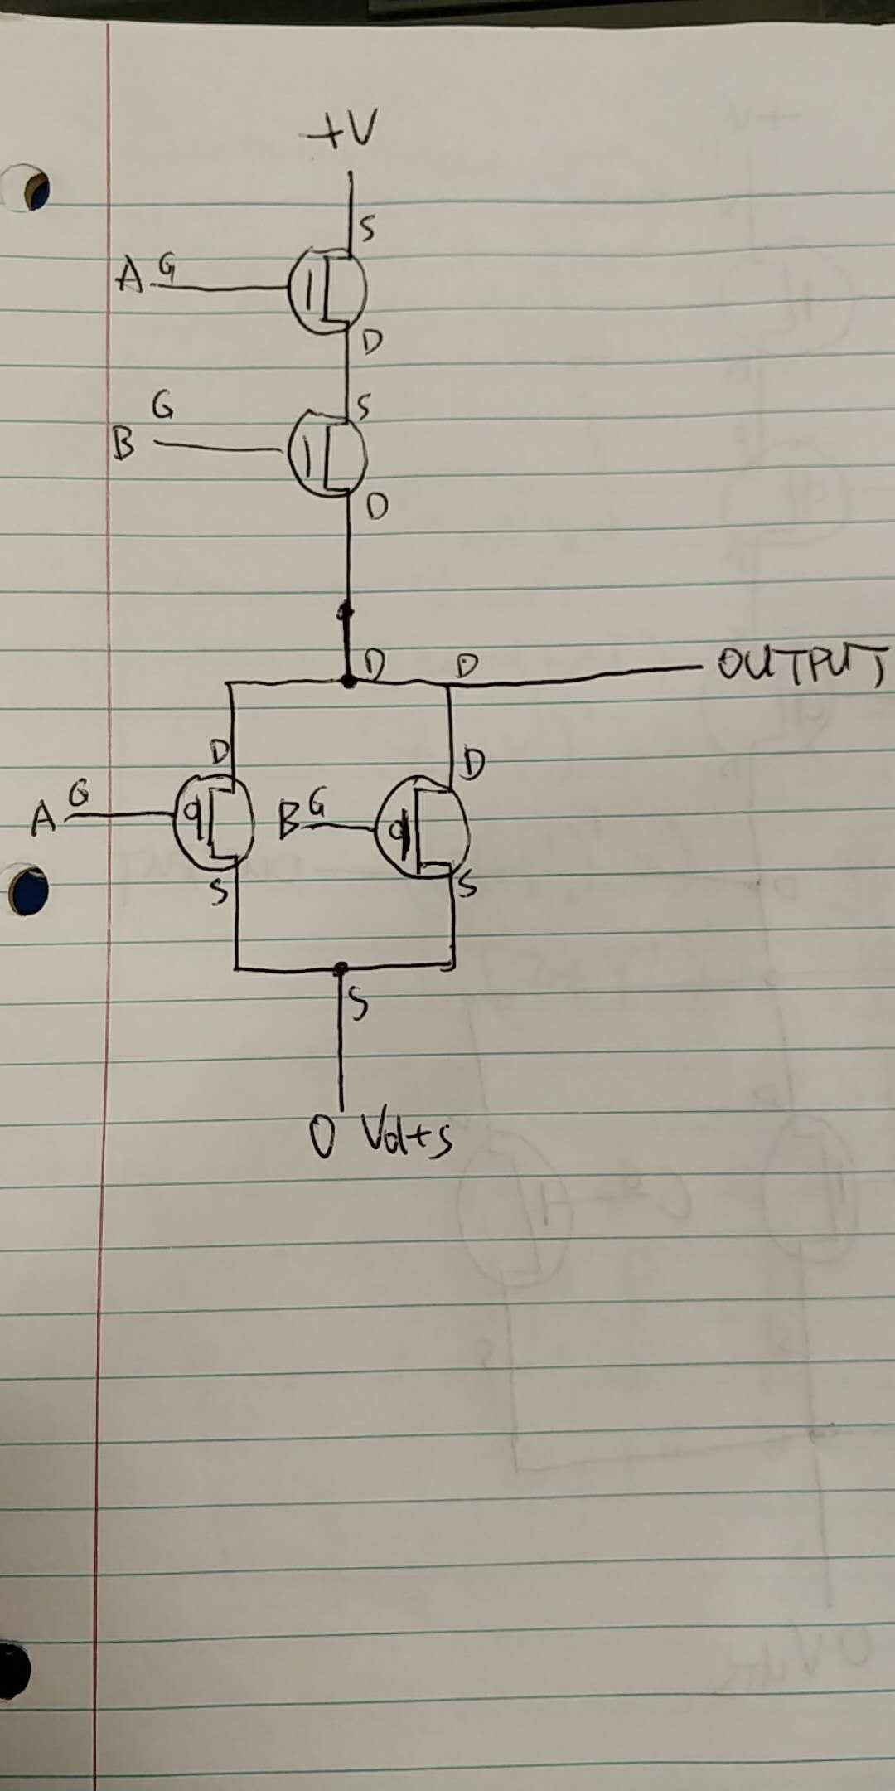

Because AND and NAND’s outputs are exactly opposite (0 to 1 and 1 to 0) with each same input, that means all we need to do is make sure the conditions that once connect high volts to output are now connect 0 volt to output, those once connect 0 volt to output are now connect high volts to 0 volt. So, all we need to do is flip the placements of +V and 0 Volt.

1. Under what conditions does a full adder generate Sum = 1 and Carry out = 0 from Augend, Addend, and Carry in? Show your answer in the form of a table.

|  |  |  |
| --- | --- | --- |
| Augend | Addend | Carry in |
| 1 | 0 | 0 |
| 0 | 1 | 0 |

1. What are the three key ideas behind making a circuit behave digitally?

1. The circuit can output two discrete values (0 volt and +V, with some margin differences) so we can use them to represent 0 and 1.

2. We adopt a certain level of approximation. For example, we will probably consider 4.9V as 5V, 0.1V as 0V.

3. Circuit can change output voltage quickly.

1. What principle allows for the simplification of descriptions of hardware or software by omission of detail?  
   The interface of a component should be independent of its implementation. We don’t need to show all the ugly details to others, all we care is others understand the implementations, functionalites of them.
2. What element in pure crystal form was used to make the first transistor?  
   High quality germanium (Ge) crystal made in a Purdue Physics lab in the room now serving as PHYS 201.
3. Why cannot a computer perform addition on the Natural numbers?

A finite amount of hardware cannot represent every element of a set that has infinite cardinality